Get Token and verify token with user

- Create user from the keyloak :
- User: vibollong
- Password: admin

- Start keyloak

>> kc.bat start-dev

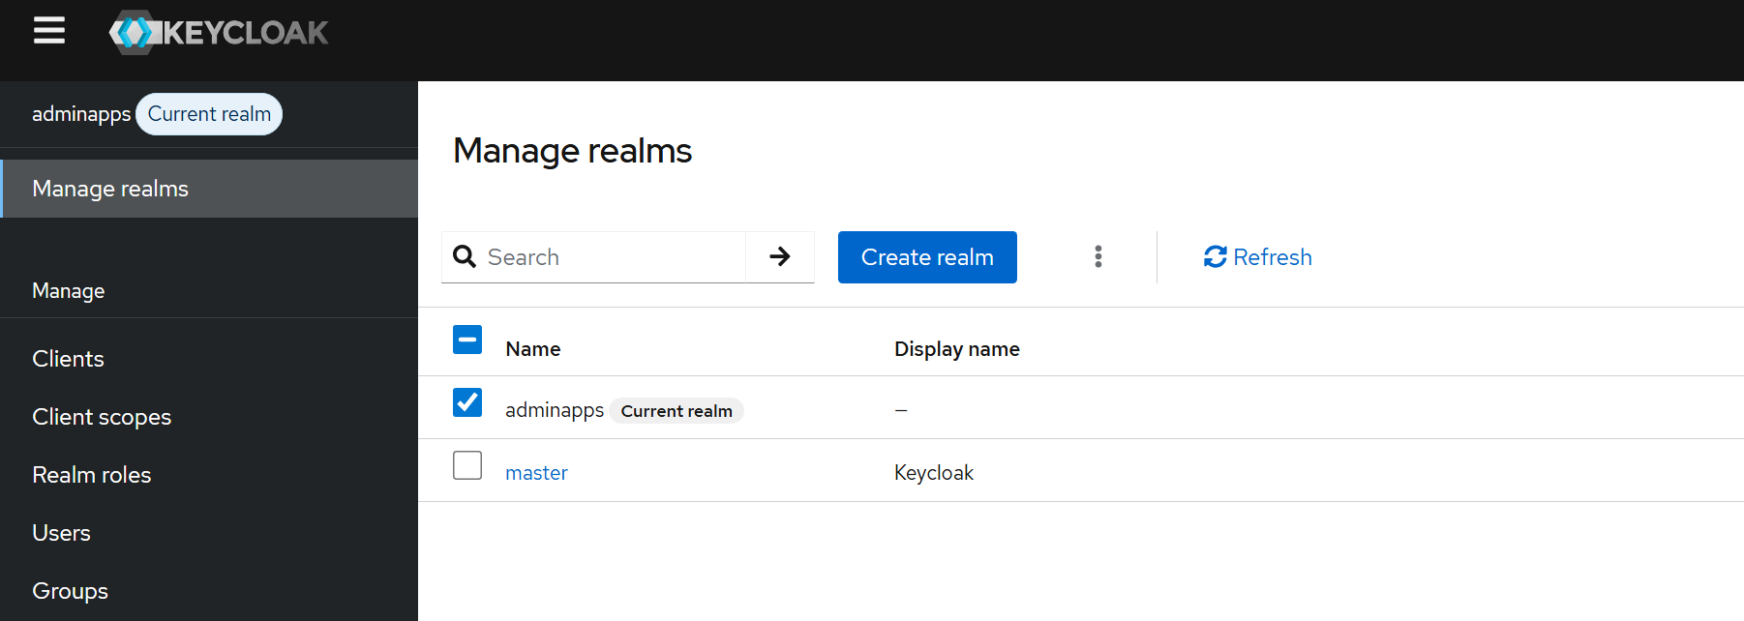

- Secret key

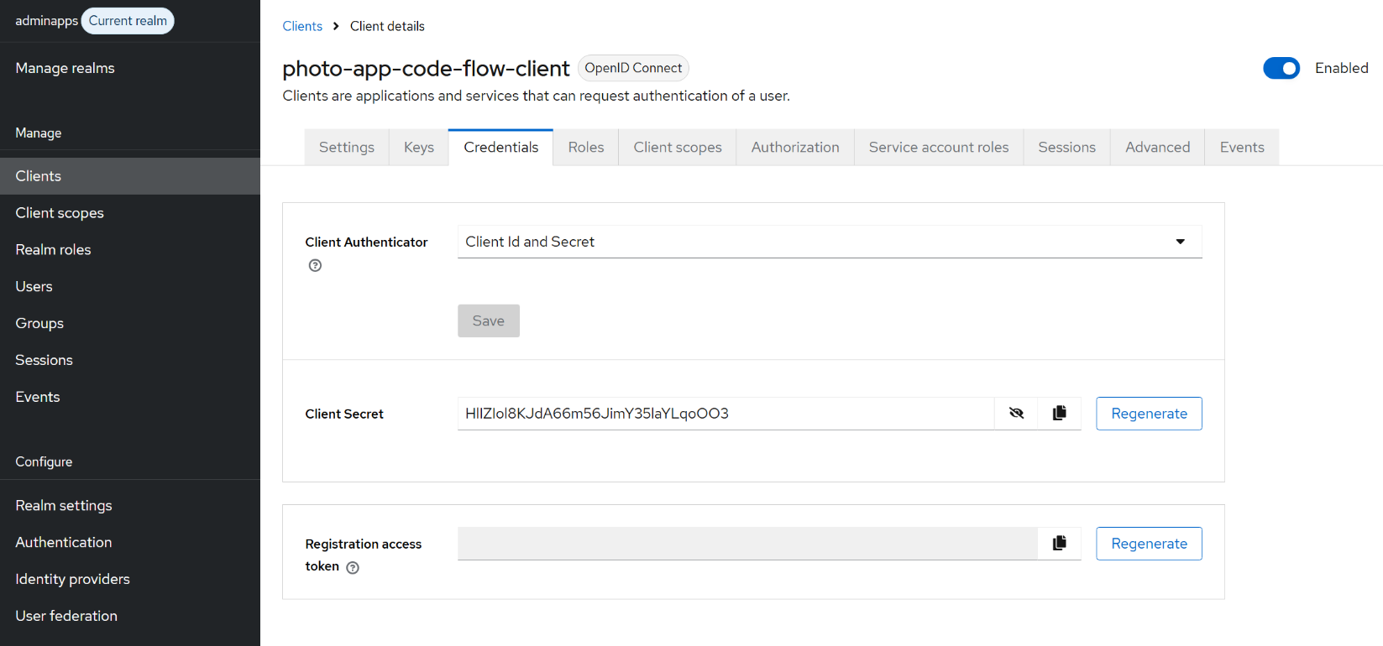

Get the code from the brower :

GET Method: Postman

http://localhost:8080/realms/adminapps/protocol/openid-connect/auth?client_id=photo-app-code-flow-client&response_type=code&scope=openid profile&redirect_uri=http://localhost:8083/callback&state=lerjerwsdfe

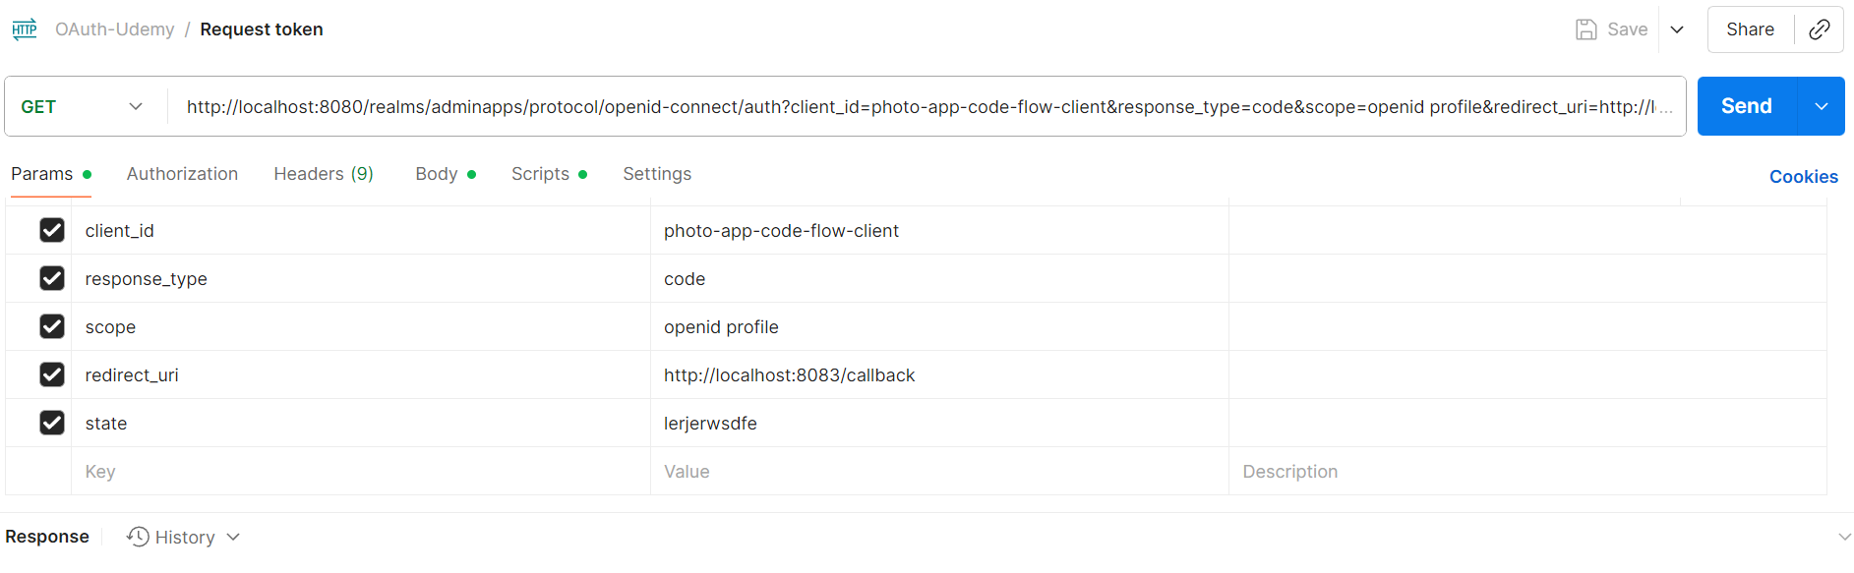

Go to brower then paste the url: then it will directly to the login brower :
Then it will get the respond back;

http://localhost:8083/callback?state=lerjerwsdfe&session_state=fXH-XmgLSFmi2ehTiFoC7ibe&iss=http%3A%2F%2Flocalhost%3A8080%2Frealms%2Fadminapps&code=130017f0-1de8-c6ce-9145-f0328e7aee49.fXH-XmgLSFmi2ehTiFoC7ibe.13d79a21-40c1-4a94-b6ab-a308b826854b

- code=130017f0-1de8-c6ce-9145-f0328e7aee49.fXH-XmgLSFmi2ehTiFoC7ibe.13d79a21-40c1-4a94-b6ab-a308b826854b

- client secret: HlIZIol8KJdA66m56JimY35laYLqoOO3

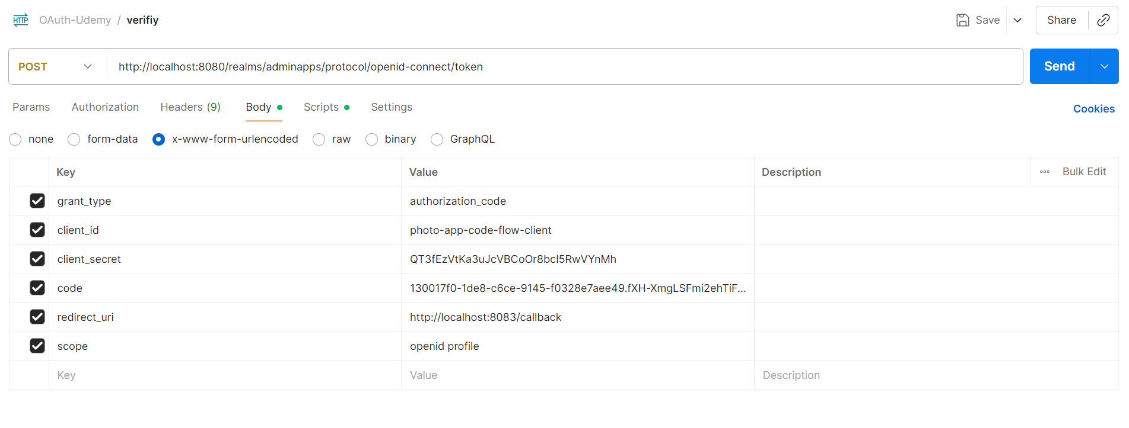

This is what we get:

